Aggregate Function

1. Write a query to list the number of jobs available in the employees table.

Ans:- SELECT COUNT(DISTINCT JOB_ID) FROM employees;



1. Write a query to get the total salaries payable to employees.

Ans:- SELECT SUM(SALARY) FROM employees;

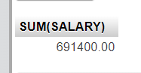

1. Write a query to get the minimum salary from employees table.

Ans:- SELECT MIN(SALARY) FROM employees;



1. Write a query to get the maximum salary of an employee working as a Programmer.

Ans:- SELECT MAX(SALARY) FROM employees WHERE JOB_ID = 'IT_PROG';



1. Write a query to get the average salary and number of employees working the department 90.

Ans:- SELECT AVG(SALARY), COUNT(DEPARTMENT_ID) FROM employees WHERE DEPARTMENT_ID = '90';

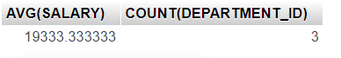

1. Write a query to get the highest, lowest, sum, and average salary of all employees.

Ans:- SELECT MAX(SALARY), MIN(SALARY), SUM(SALARY), AVG(SALARY) FROM employees;



1. Write a query to get the number of employees with the same job.

Ans:- SELECT JOB_ID, COUNT(*) FROM employees GROUP BY JOB_ID;



1. Write a query to get the difference between the highest and lowest salaries.

Ans:- SELECT MAX(SALARY) - MIN(SALARY) DIFFEREANCE FROM employees;



1. Write a query to find the manager ID and the salary of the lowest-paid employee for that manager.

Ans:- SELECT MANAGER_ID, MIN(SALARY) FROM employees WHERE MANAGER_ID IS NOT NULL GROUP BY MANAGER_ID ORDER BY MIN(SALARY) DESC;

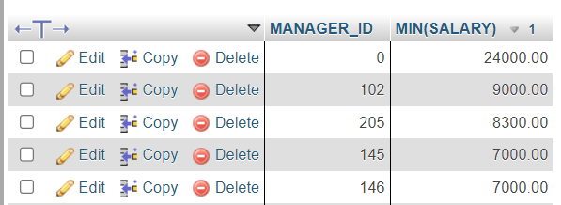

1. Write a query to get the department ID and the total salary payable in each department.

Ans:- SELECT DEPARTMENT_ID, SUM(DEPARTMENT_ID) FROM employees GROUP BY DEPARTMENT_ID;

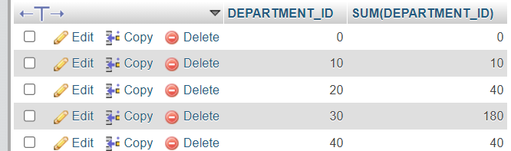

1. Write a query to get the average salary for each job ID excluding programmer.

Ans:- SELECT JOB_ID, AVG(SALARY) FROM employees GROUP BY JOB_ID;

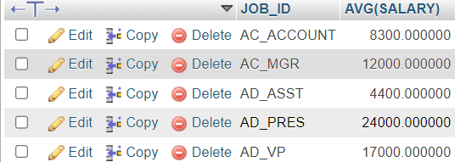

1. Write a query to get the total salary, maximum, minimum, average salary of employees (job ID wise), for department ID 90 only.

Ans:- SELECT JOB_ID, MAX(SALARY), MIN(SALARY), SUM(SALARY), AVG(SALARY) FROM employees WHERE DEPARTMENT_ID = 90 GROUP BY JOB_ID;



1. Write a query to get the job ID and maximum salary of the employees where maximum salary is greater than or equal to $4000.

Ans:- SELECT JOB_ID, MAX(SALARY) FROM employees GROUP BY JOB_ID HAVING MAX(SALARY) >= '4000';

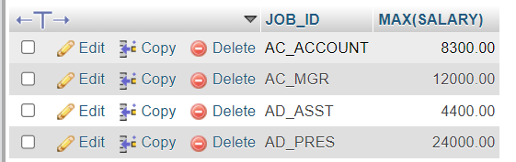

1. Write a query to get the average salary for all departments employing more than 10 employees

Ans:- SELECT DEPARTMENT_ID, AVG(SALARY) FROM employees GROUP BY DEPARTMENT_ID HAVING DEPARTMENT_ID > '10';

